Creating A Data Model Of Lumiq Firm Employee Using Case Scenario to Retrieve Data Of Their City To Which They Belong:

There are 4 employee in the firm their respective info is given

* Data Of Employees

- PersonID(int)
- LastName(varchar)
- FirstName(varchar)
- Address(varchar)
- City(varchar)

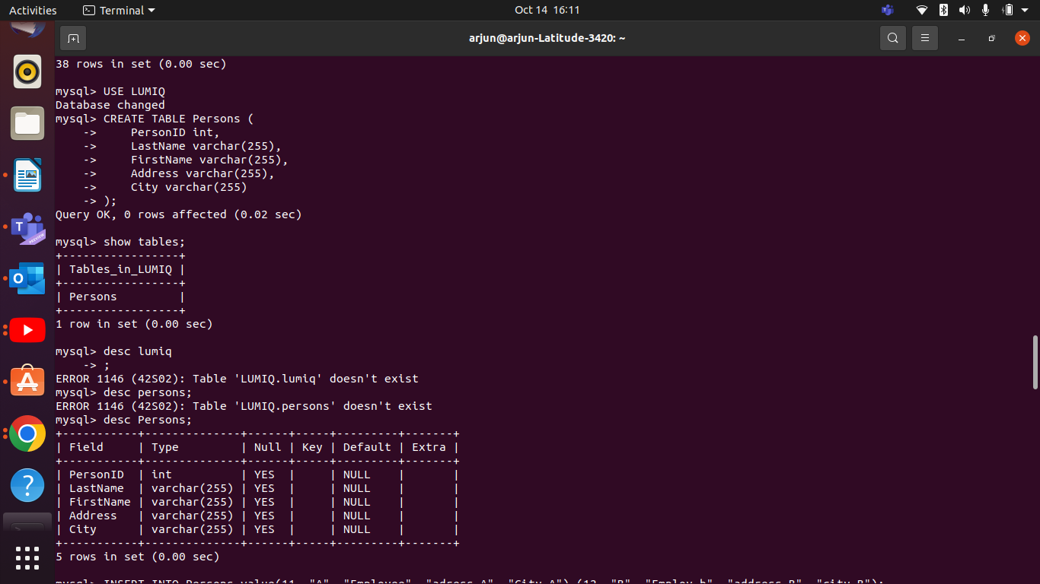

* Data Value of Employees

1.
-11
-A
-Employee
-adress A
-City A

2.
-12
-B
-Employ b
-address B
-city B

3.
-31
-C
-EmployeeC
-adressC
-CitycA

4.
-32
-CB
-Employ Cb
-adress DB
-CityD B

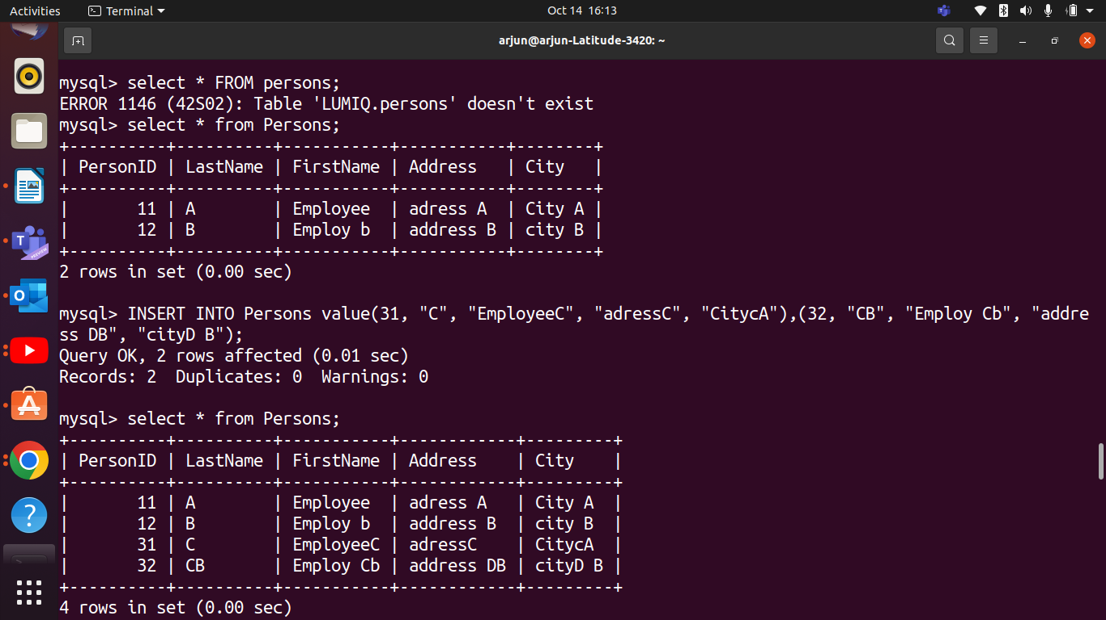

* Data Retreiving using Case Scenario via USE Primary Key PersonID:

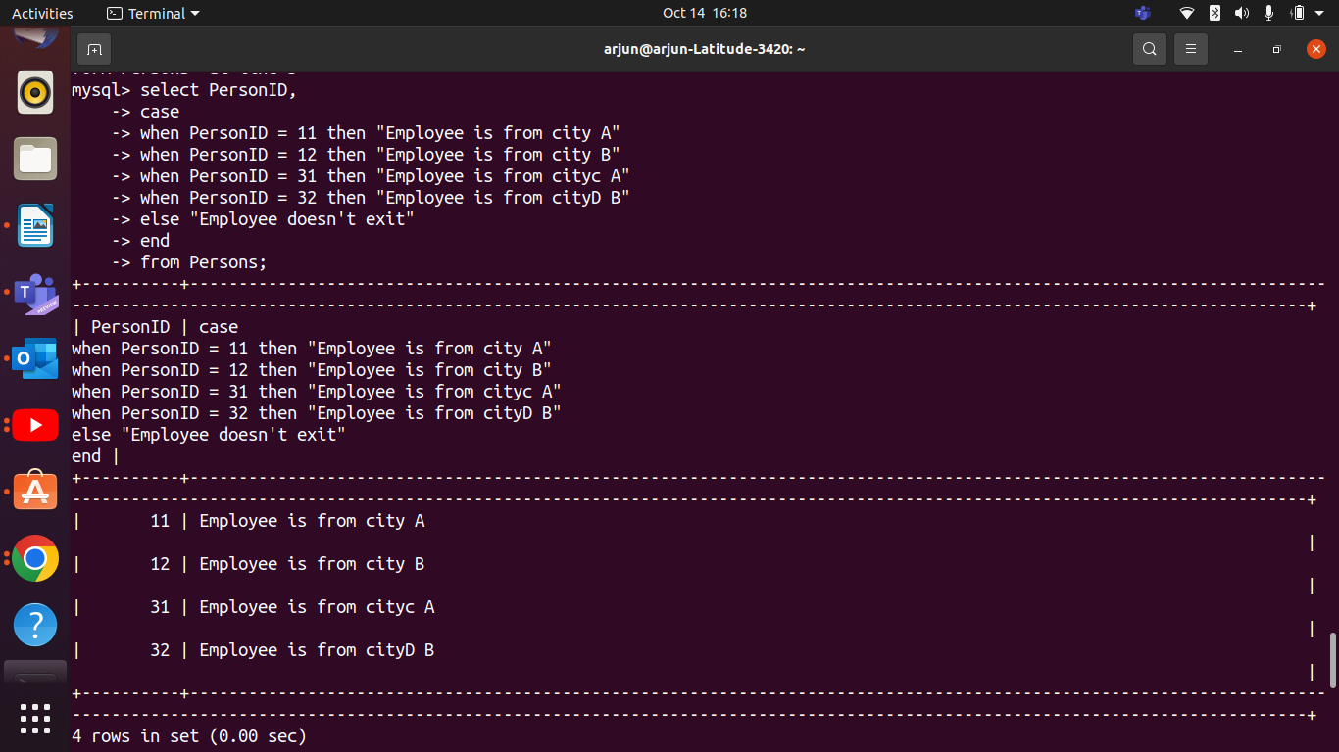

* DATA RULES:

-using only primary key ie. PersonID we have to retreive Data Of The City to which an Employee belong.

eg. if Employee ID is 11
thn it will give Employee is From City A.

* Database Type Used:

In this case I have used the Object-Oriented Databases, as there is no hierarchy in this model we have to only be object that is THE CITY to which an Employee belong have to find using PRIMARY KEY ie. PersonID.

*ER-Diagram

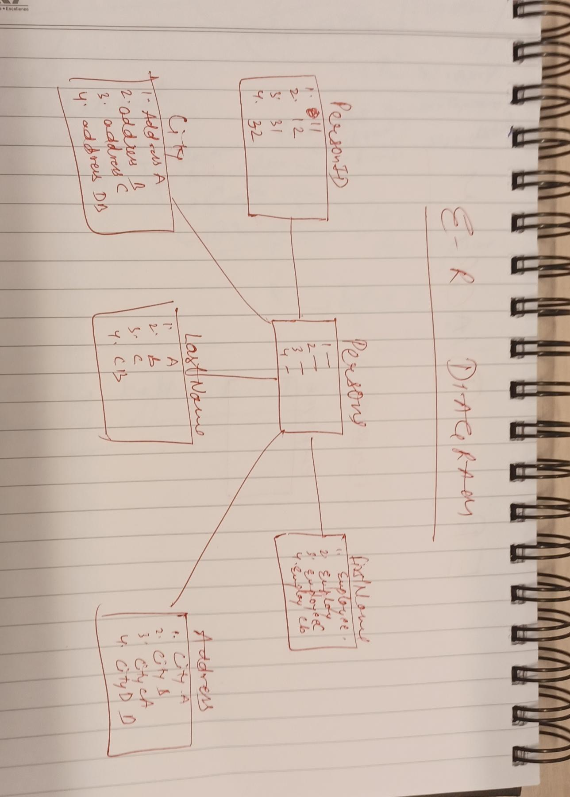
Use of Foreign Key and inner join:

